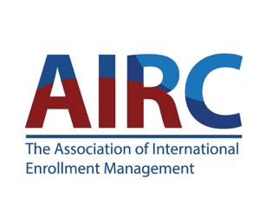
AIRC IEM Standard Completion in Relationships with Third Parties

Description:
This badge certifies competence in applying IEM Standards' Guidelines 3.4: Relationships with Third Parties, including Educational Agencies and Service Providers The IEM Standards promote ethical and transparent IEM policies and practices at the highest levels of professionalism. They provide guidance to higher education institutions to best serve international students through supporting the institution itself together with its recruitment partners, including educational agencies and service provider organizations.
The badge aligns with the AIRC Standards for higher education international enrollment management (https://www.airc-education.org/standards-and-resources-landing#higher-educational-instituiton-standards)

